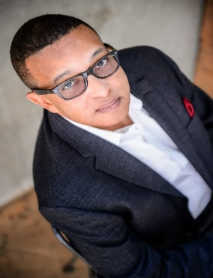Pastor Danny Hudson is an international award-winning singer/songwriter, motivational speaker and humanitarian. Winning his first talent show at the age of 10, would be the springboard for a lifelong love of music and writing. Enlisting in the United States Army out of high school, Pastor Hudson began honing his skills as a singer and songwriter. He joined an awesome choir called God’s Children, which performed all over the state of Texas. During that time, he also wrote for a group called the Sons of Faith; made up of a few of the men from God’s Children Choir. From Fort Hood, TX to Sacramento, CA and to Germany, Pastor Hudson has continually enjoyed music, both singing and writing.

His life changed dramatically in 1988 when on his way to work he was involved in a head on collision that almost took his life. Waking up in a hospital bed in Fairfax, VA caused him to realize that God had spared his life for a purpose. Since his service in the United States Armed Forces, Pastor Hudson has felt compelled to serve the community in a variety of ways. He believes that our life experiences mold us spiritually and lead us to our own spiritual calling. In 2014, Pastor Hudson founded Calvary Worship Center in Newnan, Georgia; a non-denominational congregation offering worshipers a place of acceptance, encouragement, healing and inspiration.

Pastor Hudson released his debut Album, “Wash Me All Over”, at Purified Living Ministries Church in Newnan, GA in January 2017. Since that release, Pastor Hudson has won numerous awards, including New Artist of the Year from the Prayze Factor People Choice Awards in September 2018 and Male Vocalist of the Year at the Gospel Choice Music Awards in June 2019.

Website: www.dannyhudsonmusic.com
Instagram: dannyhudsonmusic
Twitter: @dannybhudson
Facebook. www.facebook.com/dannyhudsonmusic
Email: dhudson1961@gmail.com
Bookings: OneNationUnderGodInc@gmail.com

Phone: (470) 285-5567
Music Available: ITunes, CDBaby, Spotify, Amazon, YouTube Music, Apple Music and others.

